Instructions
- Customer Information: Fields must match the DEA Registration Certificate.

- Original Package Size: The measurement of one full, unopened package. This can be a box of vials, a single vial, a box of patches, etc.

- Count in Package: The measurement currently in each separate package. Do not add packages together. (Bottles with the same measurement can be reflected in the quantity). Each partially used bottle measurement must be listed separately.

- Quantity of Packages: The number of packages AT THE EXACT measurement listed in the Count in Package. Multiple bottles of the same measurement can be reflected here.

- Description: The drug name and/or drug brand name including the drug form (tablets, solution etc.)

- Strength: The strength of the drug per unit of measure

- NDC: The National Drug Code is a 3-segment, 10 or 11 digit number on the front of the drug label

Example
Orig. Pkg. Size | Count in Pkg. | Qty. of Pkgs. | Description (include dosage form) | Strength | NDC (National Drug Code)
10x1ml | 10x1ml | 2 | Epinephrine Injectable Solution | 1mg/ml | 54288-0103-01
100 cap | 54 cap | 1 | Cephalexin Capsules | 500mg | 65862-0019-20
1ml | 1ml | 16 | Naloxone Injectable Solution | 0.4mg/ml | 70069-0071-01
10ml | 10ml | 3 | Lidocaine Injectable Solution | 10mg/ml | 63323-0201-10
10ml | 8.4ml | 1 | Lidocaine Injectable Solution | 10mg/ml | 63323-0201-10

- Signature, Title and Date: Sign and date each page of completed form. This form may be signed by the DEA Registrant or a staff member

- Submit: Email or Fax completed Schedule I-II Inventory Form:
  - Email: info@123compliant.com Fax: (480) 659-2353

**123CL will review your inventory form, prepare an official DEA Form 222, and email you with Authorization to Ship along with instructions on the next steps.

If you have any questions or need assistance completing this form, please contact us by phone, email or online chat
(602) 612-4140 ● info@123compliant.com ● www.123compliant.com (chat will pop up)

Customer Information
Facility Name |  |  |  |  |  |  |  | Date
DEA Registrant Name
Registered Address
City |  |  |  |  |  | State |  |  | Zip
Facility Contact |  |  |  |  |  |  | Phone
Email |  |  |  |  |  |  | Fax
DEA # |  |  | DEA Expiration Date |  | State License #

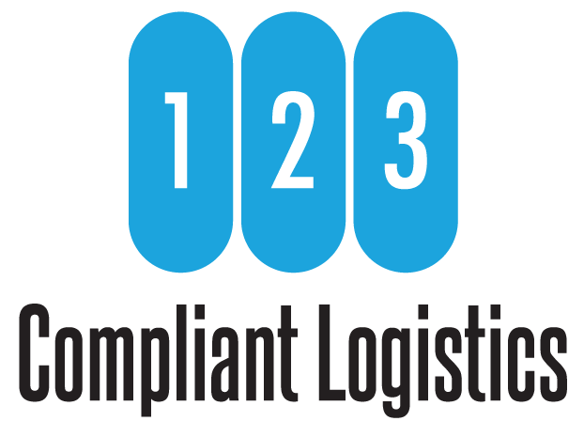
Orig. Pkg. Size | Count in Pkg. | Qty. of Pkgs. | Description (include dosage form) | Strength | NDC (National Drug Code)

