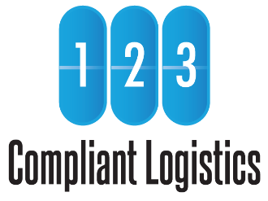

Simple Rate Box Service

Packing Guide

Questions?

Chat:
123compliant.com

Email:
info@123compliant.com

Telephone:
(602) 612-4140

Fax:
(480) 659-2353

Preparation
Gather these items and information before you begin.
- An official USPS Priority Mail Flat Rate Box (Small, Medium, or Large)
- Submit 123 Compliant Logistics (123CL) Inventory Forms for Authorization to Ship
- Make a copy of all approved 123CL Inventory Forms
- Make a copy of DEA Form 222(s)
- Zip top bags
- Packing tape
- Paper towels
- Permanent marker

Liquids
- Wrap all liquids in cushioning and absorbent material like paper towels.
- Place the wrapped liquids in a zip top bag and seal.

CII
- Segregate all CIIs by placing them in their own zip top bag and seal.
- Mark with “CII” on bag.

Pack
- All CII, CIII-V, and Non-Controlled pharmaceuticals can be packed in the same box.
- Check off all items on approved inventory forms to ensure everything is in the box.
- Place one copy of all 123CL Inventory Forms and one copy of your DEA Form 222(s) in the box. Remember to keep originals for your records.

Ship
- Contact 123CL staff and request a shipping label (please indicate box size(es) used)
- 123CL will send a prepaid USPS Priority Mail label(s) via email or fax.
- Seal the box securely.
- Affix the USPS Priority Mail label to the outside of the box.
- Give to your regular USPS Mail Carrier or scan the QR code on the USPS Flat Rate Box to schedule a pickup inside your facility from a USPS Mail Carrier.
© 123 Compliant Logistics, LLC 2023 All Rights Reserved

V.230926

