Instructions
Please complete the Sublocade® Destruction Inventory Form for all Sublocade Kits you would like to destroy
- Customer Information: Fields must match the DEA Registration Certificate

- Package Size: The measurement in milliliters of one full, unopened syringe. Sublocade is available in a 0.5ml or 1.5ml prefilled syringe

- Lot Number: The lot number can be found on the prefilled syringe. Check each syringe if you are destroying more than one as lot numbers may vary. List each lot number on a separate line

- Quantity of Packages: The number of syringes at the same package size with the same lot number

- Description: The drug name including the drug form (Sublocade solution)

- Strength: The strength of the drug in milligrams. Sublocade is available in 100mg/0.5ml or 300mg/1.5ml

- NDC: The National Drug Code is a 3-segment, 10 or 11 digit number on the front of the drug label

Example
Package Size | Lot Number | Qty. of Pkgs. | Description (include dosage form) | Strength | NDC (National Drug Code)
0.5ml | A000111US | 2 | Sublocade Solution | 100mg | 12496-0100-01
0.5ml | Z000111US | 1 | Sublocade Solution | 100mg | 12496-0100-01
1.5ml | X111333US | 1 | Sublocade Solution | 300mg | 12496-0300-01

- Signature, Title and Date: Sign and date the completed form in the space provided. This form may be signed by the DEA Registrant, or a staff member assigned to this task

- Submit: Email completed Sublocade Destruction Inventory Form to:
  - Email: order@123compliant.com

- Ship: 123CL will review your inventory form and email you a prepaid shipping label along with instructions

If you have any questions or need assistance completing this form, please contact
Patti Chittenden or Davis Brown
Operations Coordinator
(602) 612-4140
pchittenden@123compliant.com or dbrown@123compliant.com
www.123compliant.com – try our chat feature
Customer Information
Facility Name |  |  |  |  |  |  |  | Date
DEA Registrant Name
Registered Address
City |  |  |  |  |  | State |  |  | Zip
Facility Contact |  |  |  |  |  |  | Phone
Email |  |  |  |  |  |  | Fax
DEA # |  |  | DEA Expiration Date |  | State License #

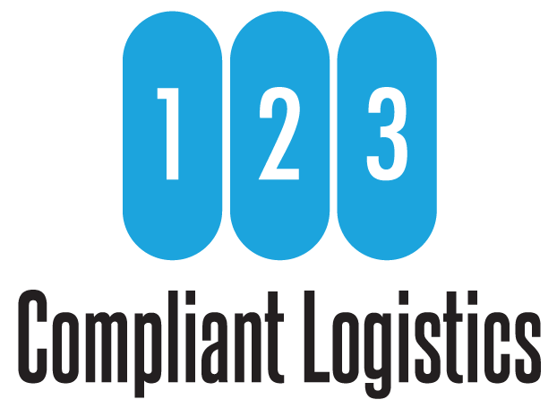
Package Size | Lot Number | Qty. of Pkgs. | Description (include dosage form) | Strength | NDC (National Drug Code)

